Introduction
The complex Dirichlet L-function $L(χ,s)≡\sum_{n=1}^{∞}{χ(n)n^{-s}}$ where $χ$ is the number theoretical character has important implication in number theories. The real Dirichlet L-function is obtained when s is real and $χ\left(n\right)=\left(\begin{matrix}n \\ m\end{matrix}\right)$ where $\left(\begin{matrix}n \\ m\end{matrix}\right)$ is the Kronecker symbol modulus m. When m=p is a prime, the Kronecker symbol equals the Legendre symbol $\left(\begin{matrix}n \\ p\end{matrix}\right)=\left\{\begin{matrix}0, n≡0 mod p \\ 1,∃x (n≢0, n≡x^{2} mod p) \\ -1,∀x (n≢x^{2} mod p)\end{matrix}\right.$. This study attempts to approximate the real L-function for prime p at s=1/2 by the partial sum $L\left(χ,\frac{1}{2}\right)≈\sum_{n=1}^{N}{\left(\begin{matrix}n \\ p\end{matrix}\right)n^{-\frac{1}{2}}}$ and compares the absolute difference as N varies across modulus p. The study observes periodic behavior of the absolute difference and existence of certain residual classes (mod p) with significantly better approximation than others. The study further characterized the types of periodic behaviors with regard to $p≡1 or 3 mod 4$, provides recipe for finding residual class N, and tries to estimate the absolute error when such N is available.

Method
For examination of residual classes behavior, the following function was built in Wolfram Mathematica,
$$R1\left(p,N\right)={Log}_{10}\left|DerichletL\left(p,\frac{p+1}{2},\frac{1}{2}\right)-\sum_{n=1}^{N}{\frac{KroneckerSymbol(n,p)}{n^{\frac{1}{2}}}}\right|$$
where built-in function $DerichletL\left(k,j,s\right)$ gives the Dirichlet L-function $L(χ,s)$ for the Dirichlet character$χ$ with modulus k and index j, built-in function $KroneckerSymbol(n,m)$ gives Kronecker Symbol $\left(\begin{matrix}n \\ m\end{matrix}\right)$. For each p, R1 is plotted against the residual classes N mod p as N varies across interval (kp+1, kp+p) for arbitrary but consistently chosen k.
For estimation of absolute error, the following function was built in Mathematica,
$$R2\left(p,k\right)={Log}_{10}\left|DerichletL\left(p,\frac{p+1}{2},\frac{1}{2}\right)-\sum_{n=1}^{kp+N}{\frac{KroneckerSymbol(n,p)}{n^{\frac{1}{2}}}}\right|$$
For each p, $1≤N≤p$ is chosen as exhibiting significantly less error. R2 was plotted against k and modeled with built-in function NonLinearModelFit.

Observation
The absolute difference display periodic behavior with period p. For example, same pattern is observed for interval (89k+1, 89k+89) for k=1, 2, 5, and 10.
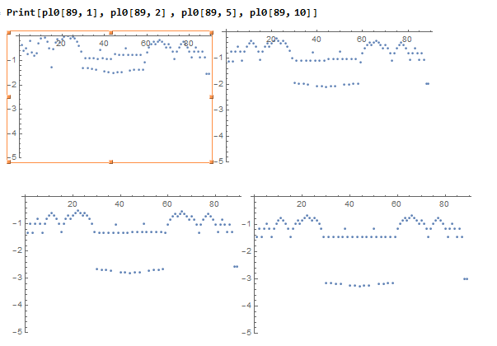

Consider the relative error $R3\left(p\right)=\frac{R1(p,N)}{\sqrt{N}}$ normalized by the upper bound, Relative error (right) and absolute error (left) has the same pattern.
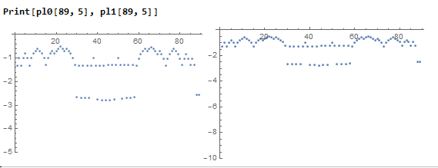

Well behaving points generally occur symmetrically with respect to residual class (p-1)/2 mod p.
Remark:
“Good behavior” is defined arbitrarily for each prime.
For all p = 1 mod 4, p and p-1 are well-behaving points that has no image upon reflection across (p-1)/2; otherwise the symmetry is preserved. Moreover, (p-1)/2 is a well behaving point for all such p. (For example 73 = 1 mod 4. 71, 72 are well-behaving point lacking symmetry; 36 is a well behaving point. )
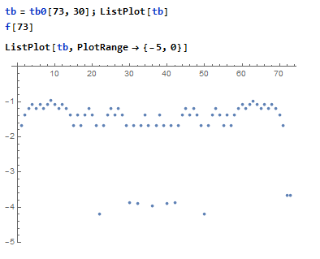
For p =3 mod 4, symmetry is sometimes broken as a well-behaving cluster centered on (p-1)/2; such cluster, including the case of single point, occur iff (p-1)/2 is not a square. (for example 127 =3 mod 4, and 63 is not a square mod 127. Cluster occurs around, and contains, 63. )
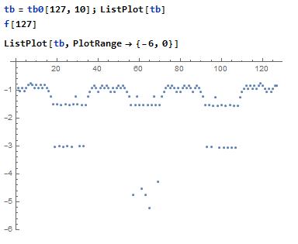
If the (p-1)/2 is a square, then there exist other squares, such that the square is a well-behaving point. (for example, 131=3 mod 4 and 65 is a square mod 131. Several, but not all of the well-behaving points are squares. )
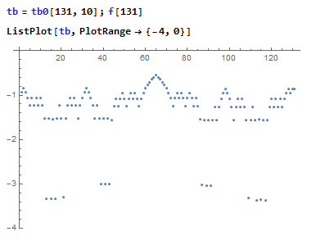

For all p=3 mod 4, $ϕ\left(p-1\right)=ϕ\left(\frac{p-1}{2}\right)$; for all p=1 mod 4, $ϕ\left(p-1\right)=2ϕ\left(\frac{p-1}{2}\right)$, where $ϕ\left(n\right)$ is the Euler’s totient function giving the number of positive integer relatively prime to n.

For a given residual class, the absolute value of remainder decay as 1/x, where x is the interval (x(p-1)+1, xp). For example, the following graph is p=13 with upper bound at (p-1)/2 across from the 1st to the 30th interval.
